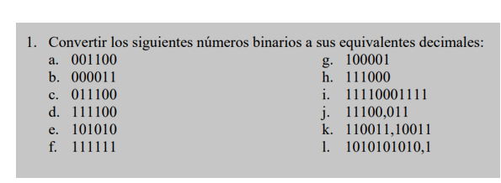

A=12

B=3

C=28

D=60

E=42

F=63

G=33

H=56

I= 1935

J=28.375

K=51.79

L=682.5

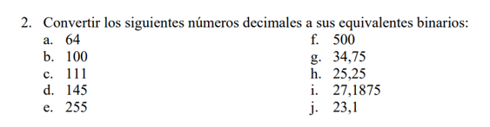

A=1000000

B=1100100

C=1101111

D=10010001

E=11111111

F=111110100

G=100010.11

H=11001.1

I= 11011.0011

J=10111.0001100110011

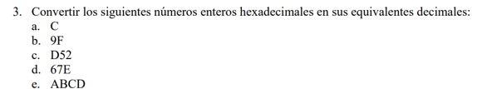

A=12

B=159

C=3410

D=1662

E=43981

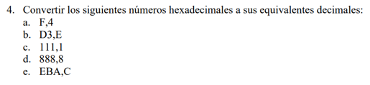

A=15.25

B=211.875

C=273.0625

D=2184.5

E=3770.75